**THE UNIVERSITY OF NORTHAMPTON**

**(NAMI COLLEGE)**

**Report for web (Term 1)**

NAME: MILAN SHRESTHA

UN ID: 16418532

Github link: https://github.com/milan1423/csy1018-assign1

**CONTENTS: pages**

1. Getting started 3
2. Designs 3

2.1 Sketches 3

2.1.1 Sketch for home page 4

2.1.2 Sketch for biography page 5

2.1.3 Sketch for CV page 6

2.1.4 Sketch for contact page 7

2.1.5 Sketch for mobile responsive 8

3. Final designs 10

3.1 Home page for desktop 10

3.2 Biography page for desktop 10

3.3 CV page for desktop 11

3.4 Contact page for desktop 11

* 1. Final mobile view 12

1. Working progress 14
2. Good Practice 15
3. Conclusion 16
4. Reference 17

1. **Getting Started**

First of all, honestly before starting to create my portfolio, I visited different web pages and got some ideas from them to style my portfolio. I got a lot of ideas and concept from these pages and found that people has used like HTML5 or Bootstrap. So, as in our assignment information has told us to use HTML5 so I have used HTML5 to build my web page. CSS is being used to style the page. It has completely helped me to create my own creation and design them in the way I like to do. HTML5 is a great platform to work on. So, I decided to make four pages and firstly I starts with wireframe sketches and made a design to work on. I style all pages of my website in a single CSS.

1. **Designs**

**2.1 Sketches**

2.1.1 Sketch for homepage

Navigation bar is the one of the important part of the web page so, I wanted to keep navigation bar as a header on my web page and inside this bar there is logo division and menu bar which transfers us to different page of my web site. Logo is at the left side of the whole bar and menu at the middle and search at the left side. Again inside navigation bar there is another search division and its button. When we hover in the menu section it shows different colour.

Below the navigation bar there is photo and some welcome message and background is kept on that section. The welcome massage has some animation.

Finally, at the footer part there is two division. One division is for the icons with the link about the icon and the other section is for the copyright part.

The navigation bar and the footer part is same for all the pages in my web site.

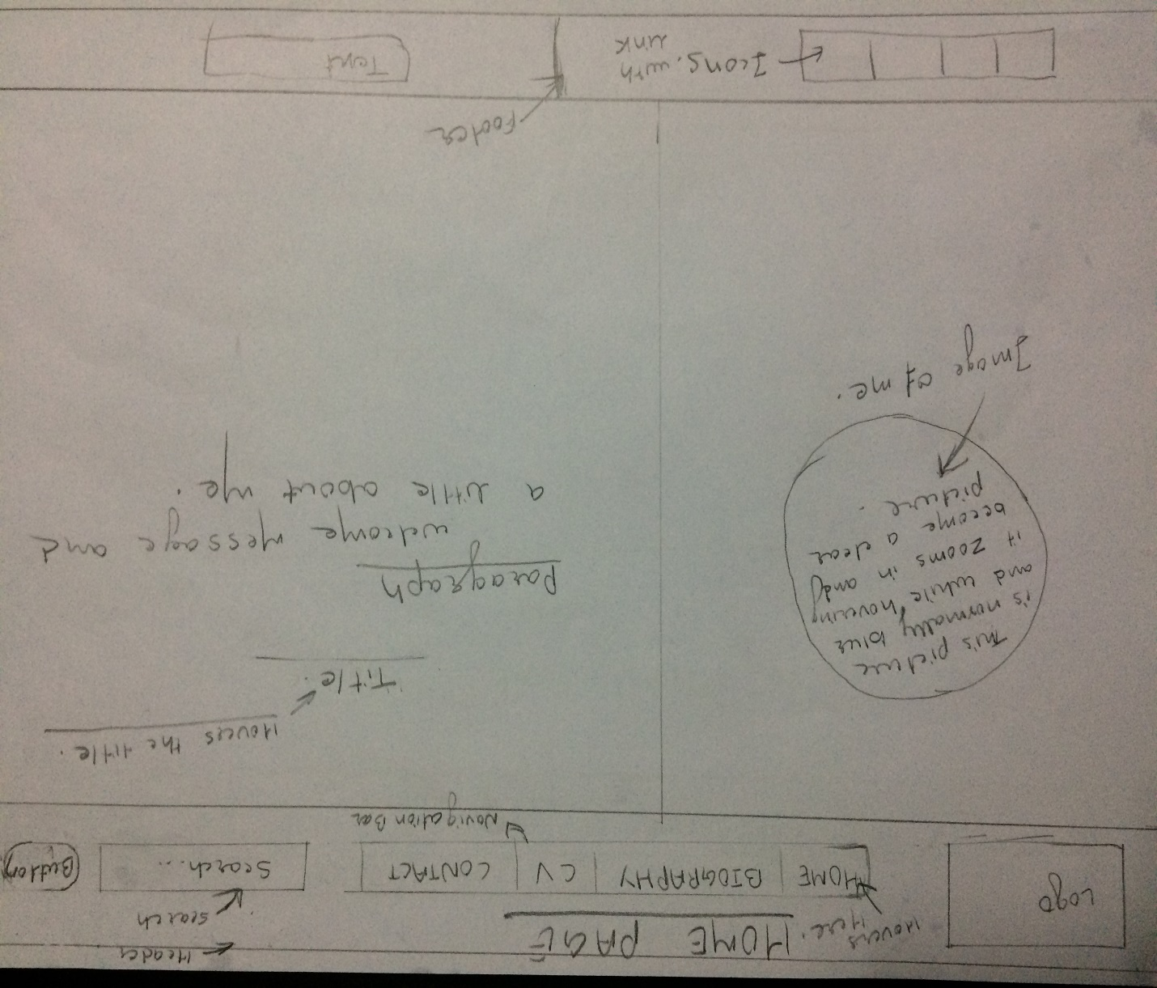

2.1.2 Sketch for biography page

For my biography page I have kept same navigation bar and same footer as of the home page. I have included something about me and at the side of the about me there is photo of me. This photo rotates in 180 degree and a little opacity is kept in that photo.

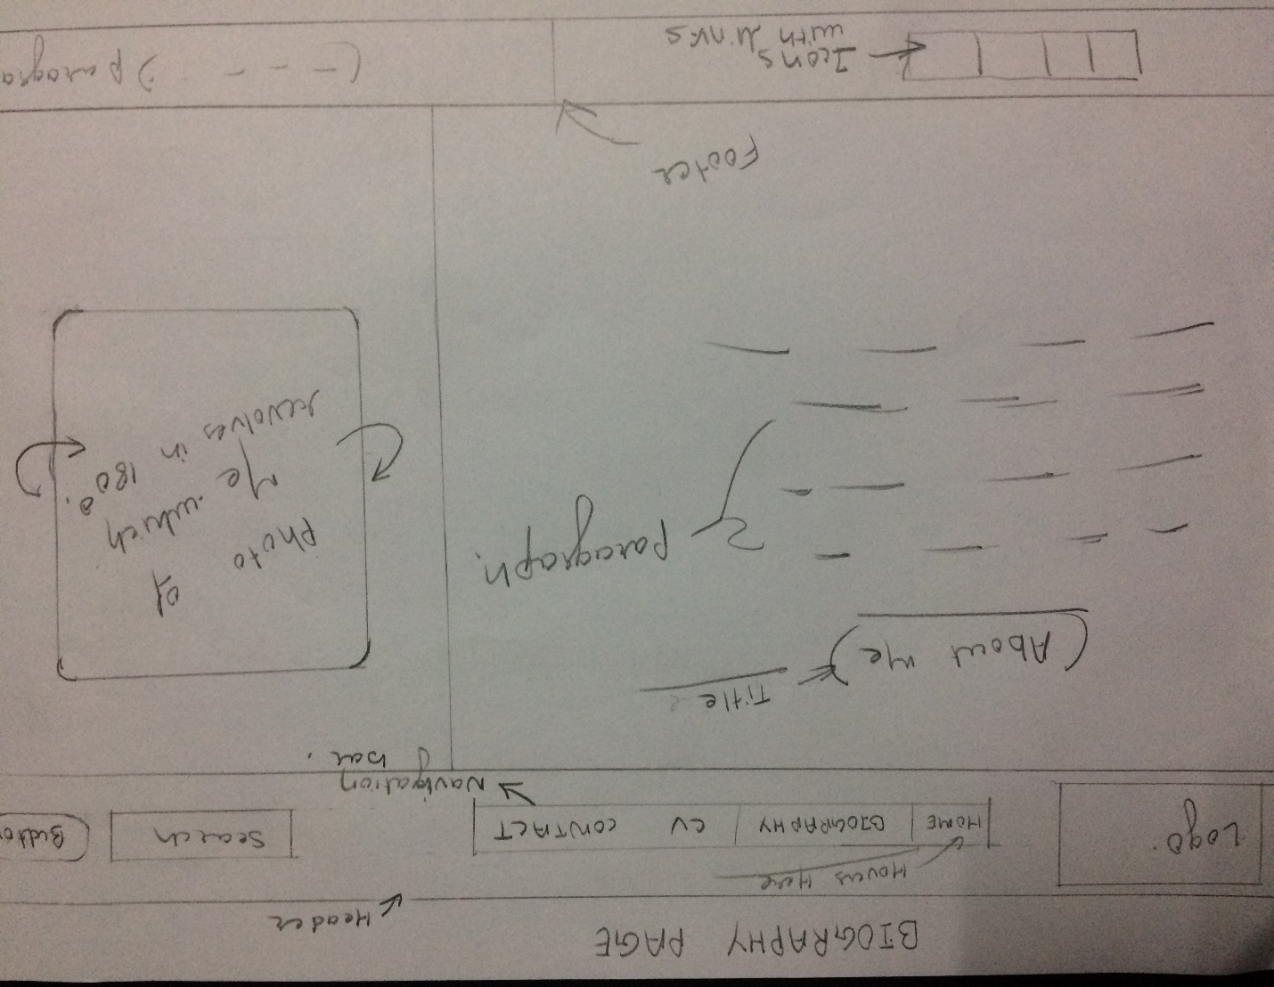

2.1.3 Sketch for curriculum vitae (CV) page

The navigation bar and the footer part is same as the home page. Inside the body part there are three divisions in the first left side division there is personal details of me and in the right side division there is my education detail, my skills and my experience. In the top division there is header and my name is written there.

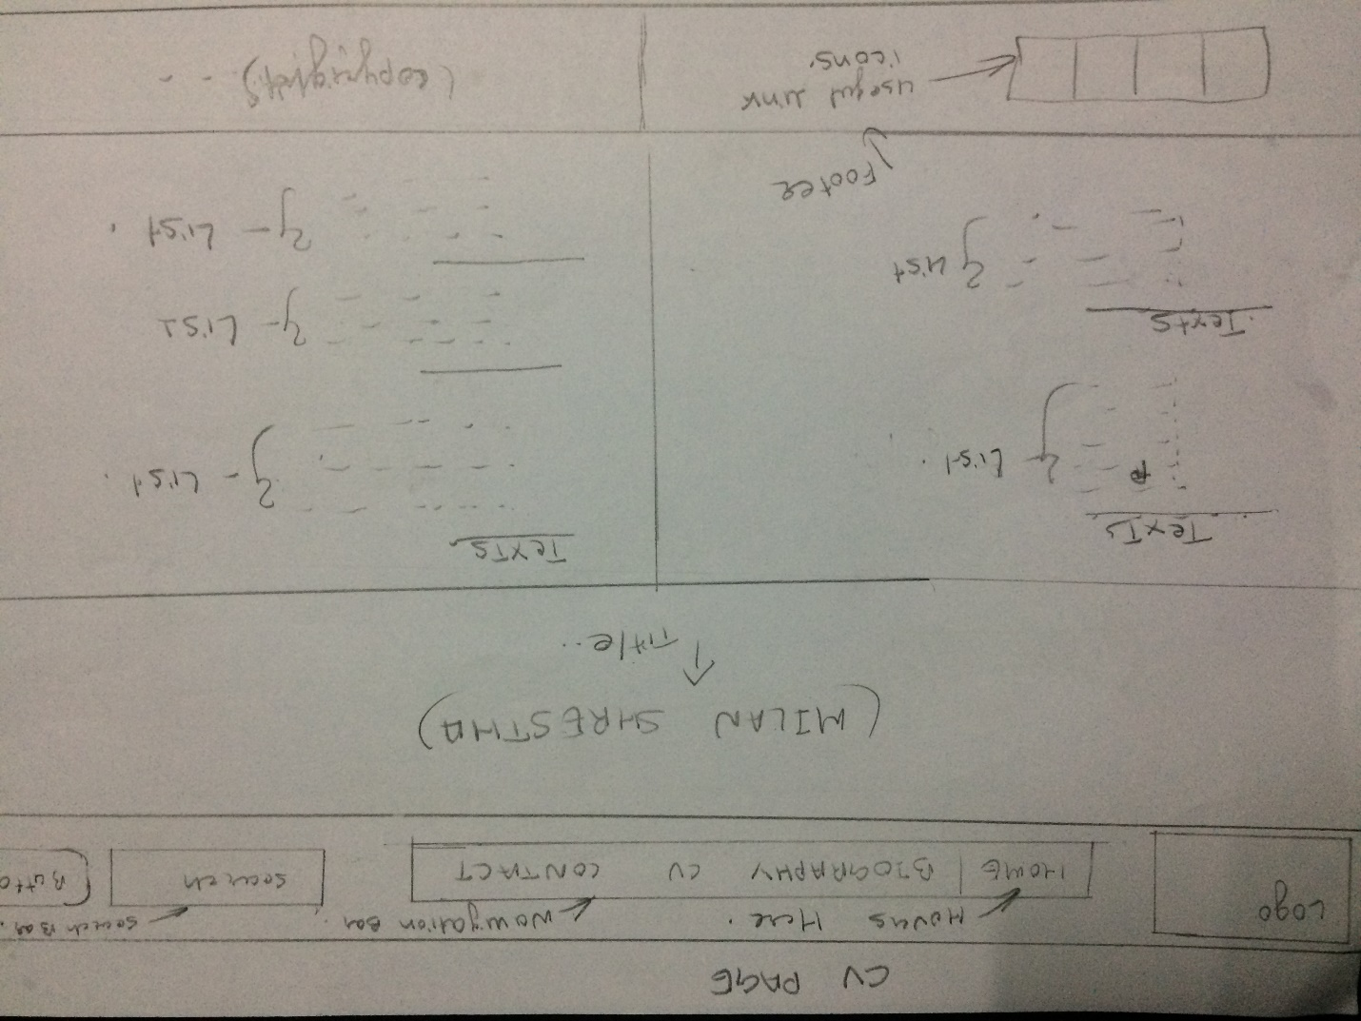

2.1.4 Sketch for contact page

In this contact page same navigation bar and footer is kept as of the home page. Inside the body there is section and in section there is three division one division is for form to send emails and contact me, second division is for my phone number and email address, and last division is for my photo as shown in the picture below.

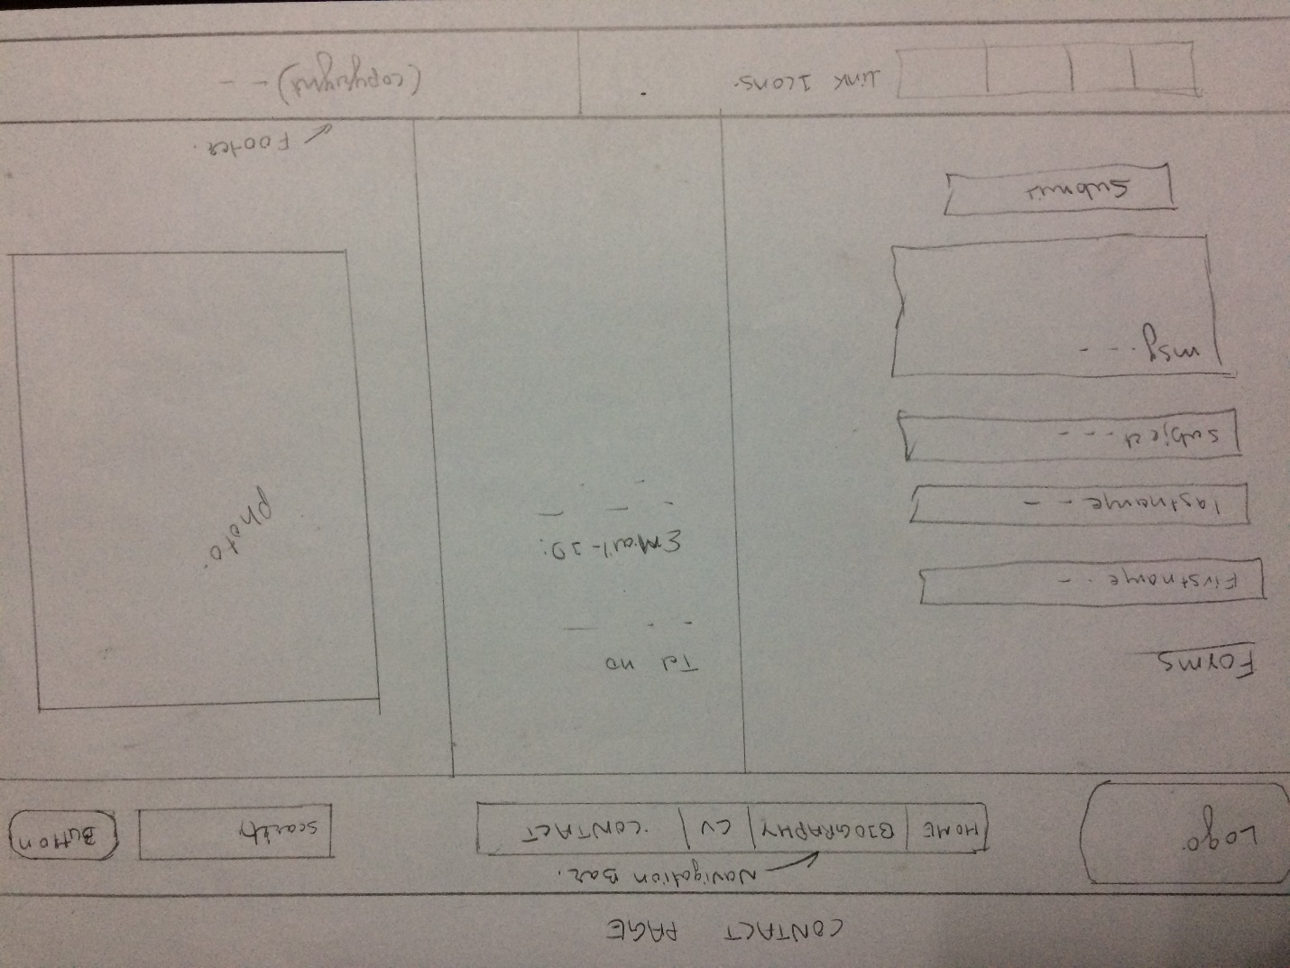

**2.1.5 Sketch for mobile responsive**

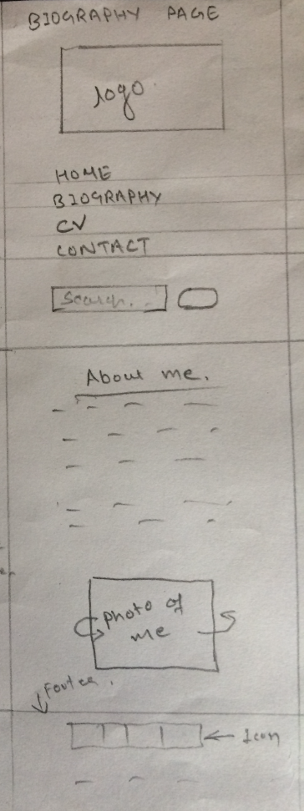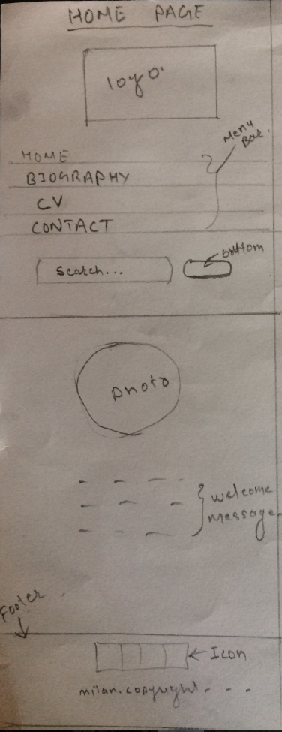In the mobile responsive page all the header, body and footer part which were in row form all becomes the column form. All the division are set to be in column. All the header and footer are same for the all pages. 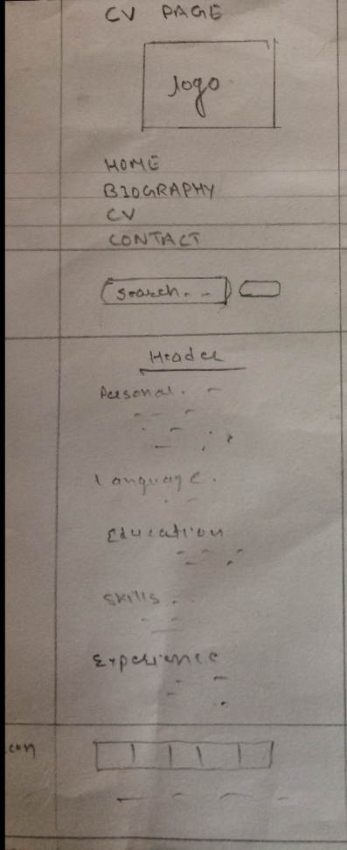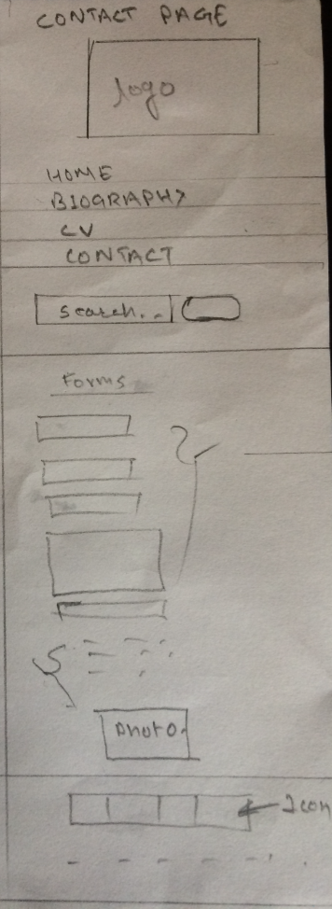

1. **Final web Designs**

In this final web design I am satisfied with my design. These designs are same as the sketches above. At the footer part there is some useful icons with the link and in navigation bar there are menu search and logo.

**3.1 Homepage for Desktop**

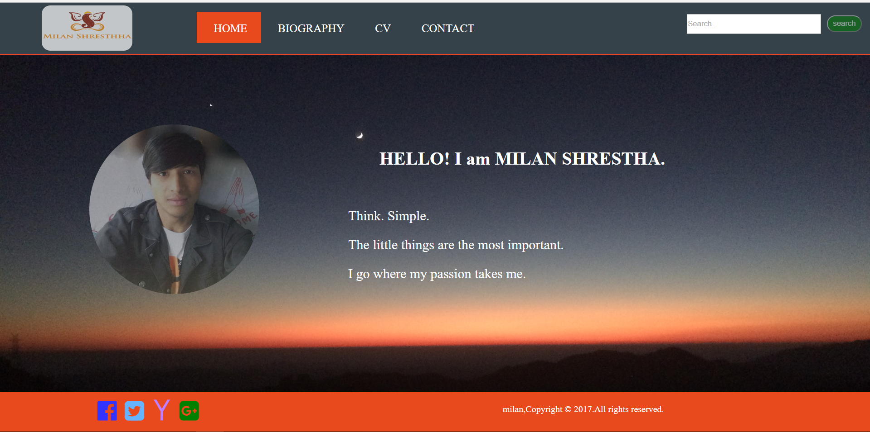

**3.2 Biography page for desktop**

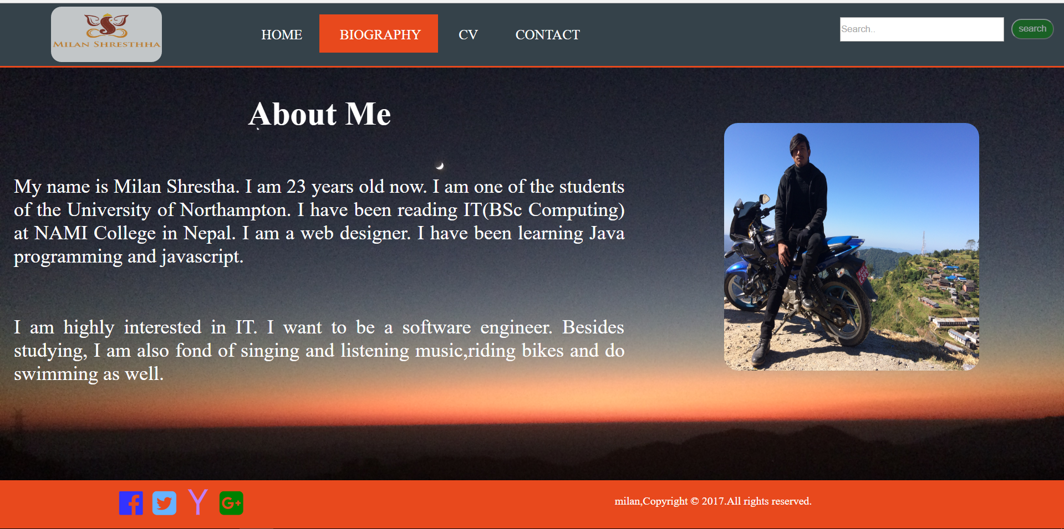

**3.3 CV page for desktop**

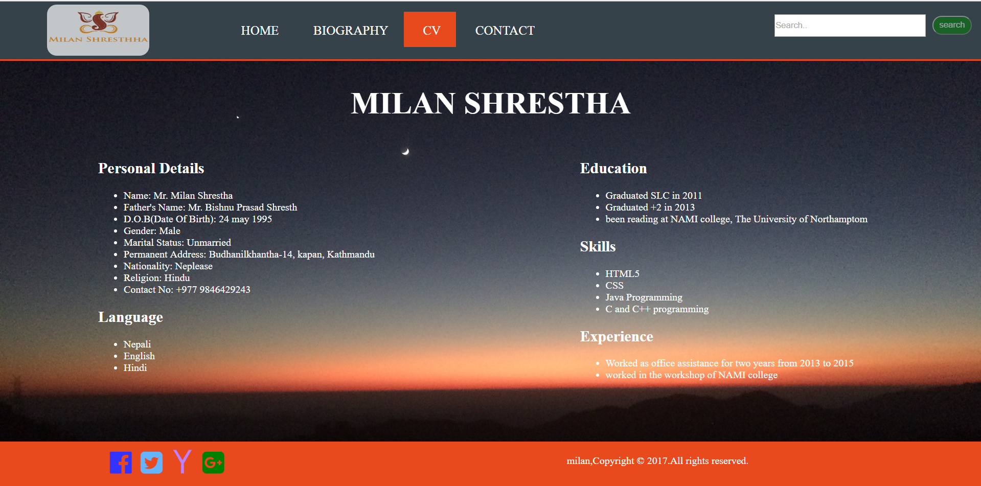

**3.4 Contact page for desktop**

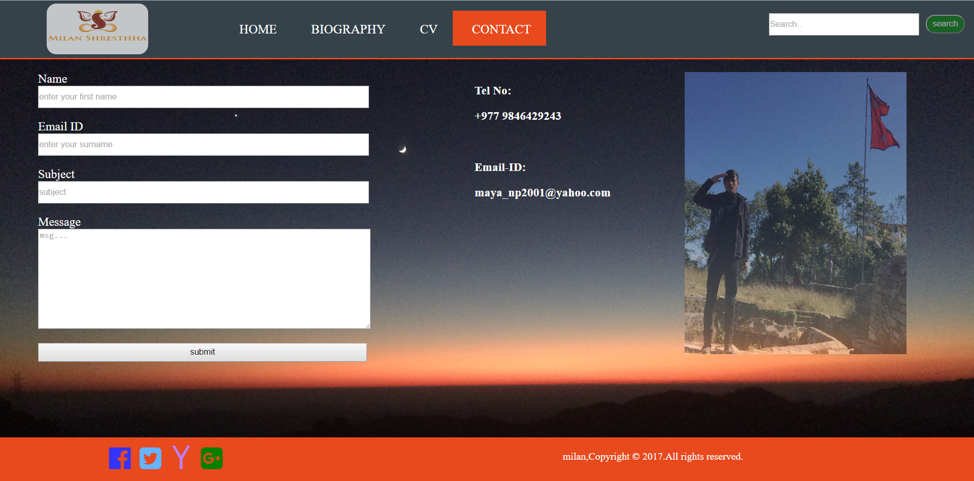

**3.5 Final Mobile View**

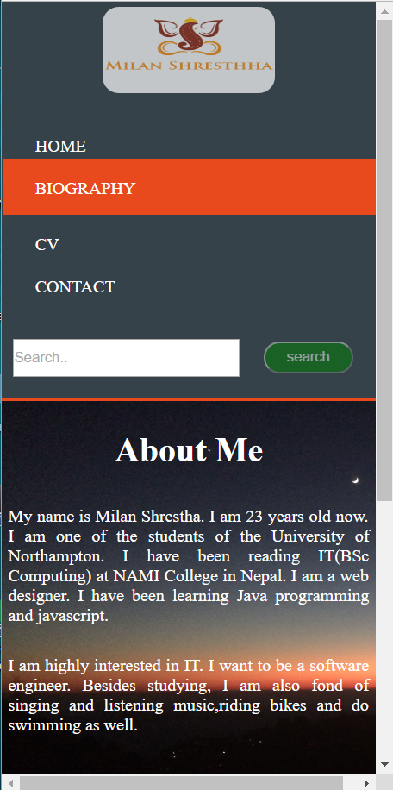 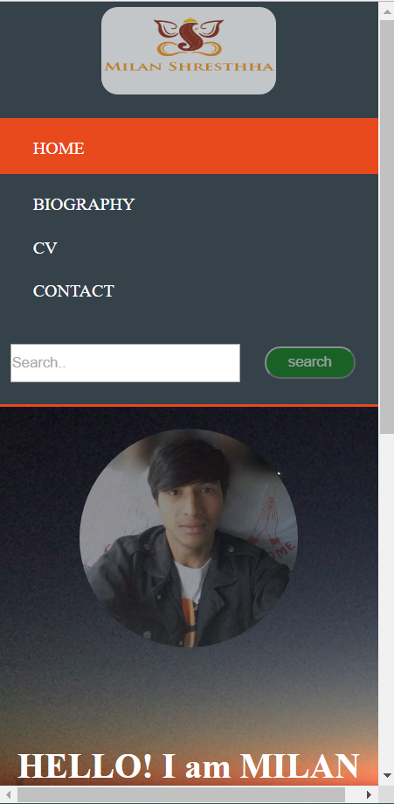

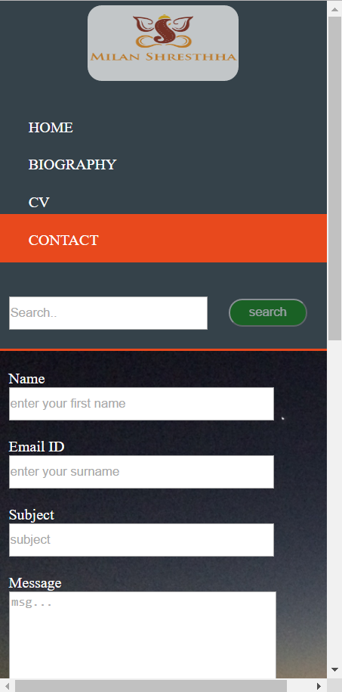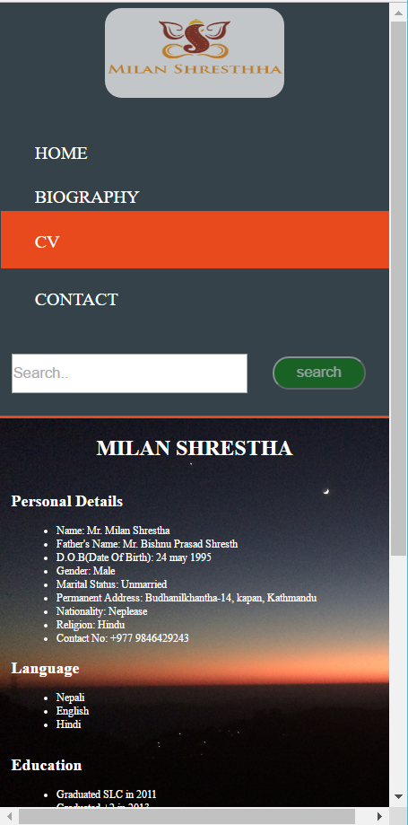

1. **Working Progress**

First of all, I had no idea about how to make the web page and I research many sites and got some idea to how to start my page development. As we have studied HTML5 to make the web page from our course and use it to make my web page. In the first week I tried to make home page and to make my web page consistency I used same navigation bar and footer for all pages. I also used CSS3 to style my home page. I also had no idea about the git hub and learned it from my teachers and friends and clone the repository from it and started to work on that repository.

In this first week I design the sketch wireframe for my page and started to work on the coding part to develop my web page. I first design my home page and kept the navigation bar and footer. And I got many problems developing the web page and take the ideas to design my footer and navigation bar. In this week I also created my biography page. I have created my own logo by using photoshop.

Later, in the following weeks same as my home page and the biography page I developed other two pages contact and CV page. Lastly I made my web page responsive for mobiles. Finally, to finish this work it nearly took 34 hours. I got many challenges while developing this web site and to overcome this challenges I consult with my module tutor and some friends. I took help from Raj kumar Phagami, Anmol Adhakari and Prabin Maharjan to make my page beautiful and good as well as responsive for mobile.

1. **Good Practise**
2. Speed test:

I have tested my website in pingdom.com. I got my webpage a bit slower than other websites because the loading time was 482ms and faster 97% and a performance grade is 88 (B).

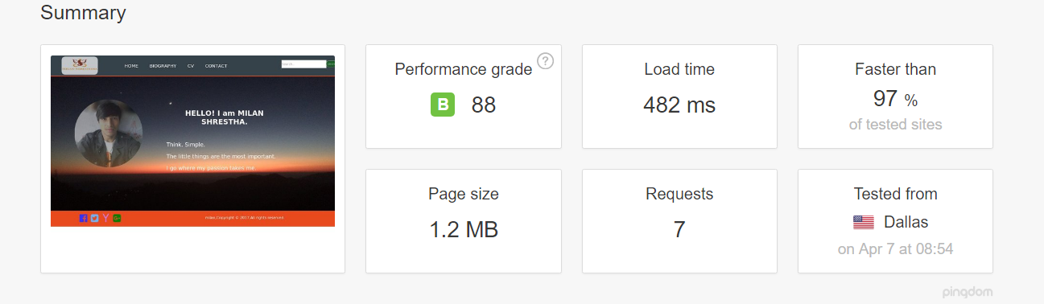

1. Social links in my page:

Some social link like facebook, yahoo, twitter and google are kept in my webpage which helps user to connect with me. This is also one of the good practise now a days. This make your web page good and easy for user to link with these social sites. It is also one of the attraction of the web page.

1. Validation test:

While I test my web page for validation there was some errors on my website and by looking at that errors I modified my codes and resolved them and later when I check there were no errors on my web page.

1. **Conclusion**

TO conclude my report, I finally learnt the HTML5 and CSS3 from this assignment. This assignment has helped me to overcome the faced problems on HTML and now I v can develop any webpages. My skills have been reached to new level with the help of this assignment.

1. **References**

W3schools.com. 2014. CSS3 Transition. [ONLINE] Available at: <https://www.w3schools.com/css/css3_transitions.asp> [Accessed 1 April 2017].

Pingdom. 2017. Website Speed Test. [ONLINE] Available at: <https://tools.pingdom.com>. [Accessed 6 April 2017].